1. Now we know the point addition and point doubling on Elliptic Curve.
2. Let’s talk about Elliptic Curve Discrete Log Problem.
3. 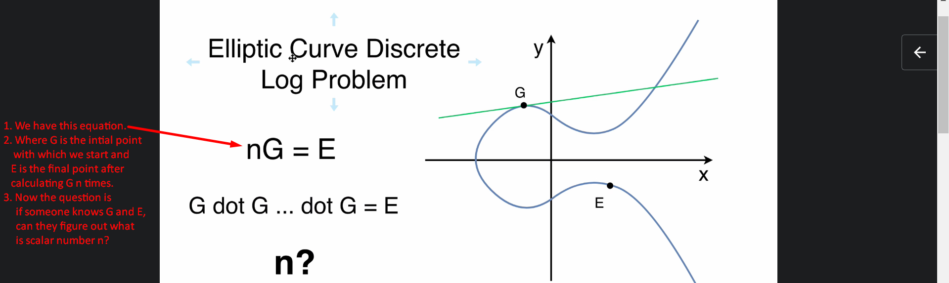
4. Answer: n can’t be determined even though we know initial point G and final point E.   
   The reason is the below:  
   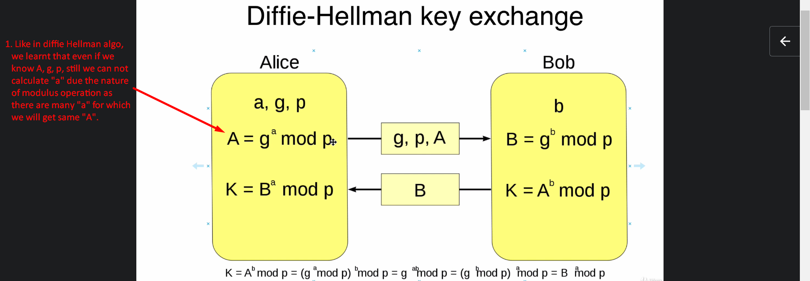
5. 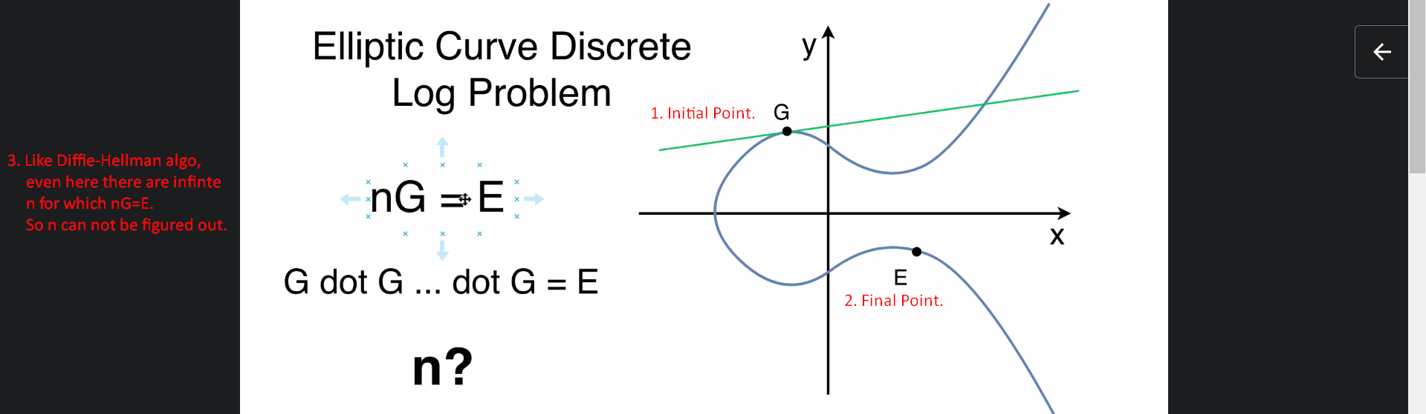
6. In next lecture, let’s see how Elliptic Curve Cryptography can be used for key generation over insecure tunnel.